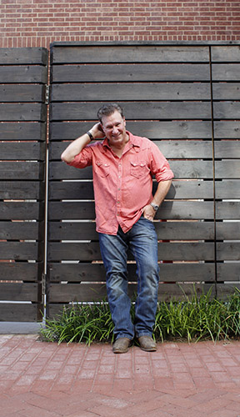
Dan Weber

Cell #: 360-737-7737

Email: deweber911@gmail.com
Web: www.danwebermusic.com

Social:
Facebook: www.facebook.com/danwebermusic
Instagram: https://www.instagram.com/danwebermusic/
Twitter: https://twitter.com/danwebermusic

Video:
1. Officially Sponsored Artist for Crossrock Cases
2. Hank and Jesus
3. Oh Woody
4. While You Were Sleeping
5. Ever Since Columbine
6. Farewell Maggie Valley
7. Goodbye to Dad
8. Take a Liking to You

Audio:
1. Spotify

2. Bandcamp
3. Soundcloud

4. iTunes

5. Amazon Music

Discography:
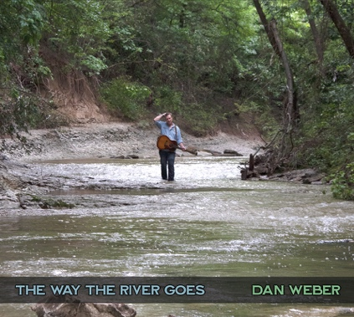  The Way the River Goes - 2020 | 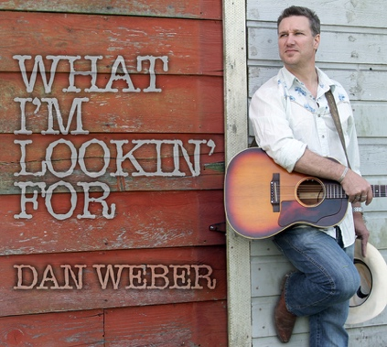  What I'm Lookin' For - 2015 | 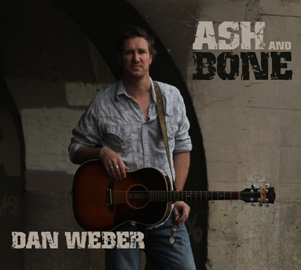  Ash and Bone - 2012

Bio's:

Download individual bio versions at danwebermusic.com

Brief:
- Born in Rochester, NY. Spent 30 years in the Pacific NW. Currently lives near Dallas, TX
- Former Park Ranger in Canyonlands National Park
- 2019 Winner of the Woody Guthrie Songwriting Contest
- 4 time Finalist in the Kerrville ‘New Folk’ competition (2021, 2015, 2014, 2012)
- 2 time Falcon Ridge Folk Festival/Grassy Hill Emerging Artist Showcase (2019, 2015)
- 2015 Winner of the Winfield, KS, Walnut Valley Festival ‘NewSong’ Showcase
- 2015 Winner of the Rose Garden Coffeehouse Songwriter Competition

Short:
Dan Weber is an award winning songwriter who has been described as "reminiscent of early John Prine." Legendary Folk troubadour Ramblin' Jack Elliott said "I love Dan’s songs and he tells really good stories."

A former Park Ranger at Canyonlands National Park, Weber draws inspiration from a wide range of life experiences: growing up as an altar boy and Eagle Scout; painting houses, following the Grateful Dead; and quitting his real estate business to pursue songwriting and touring full-time. He has a knack for telling funny stories, so if you like Guy Clark, Robert Earl Keen, or Hayes Carll, you’ll love Dan Weber’s music.

In 2019, Dan was the winner of the prestigious Woody Guthrie songwriting contest for 'Ever Since Columbine', and in 2021 he was named a rare 4 time finalist in the legendary Kerrville ‘New Folk’ songwriting competition. In 2022, he released 'The Way the River Goes', which promises to be his best work yet. He currently lives near Dallas, Texas.

Long:
Dan Weber is an award winning songwriter who has been described as "reminiscent of early John Prine" (Fatea Magazine). Legendary Folk troubadour Ramblin' Jack Elliott said "I love Dan’s songs and he tells really good stories."

"As I kid I fell in love with story songs by the likes of Jim Croce, Harry Chapin, and Gordon Lightfoot. One of my first memories is being about 5 years old, transfixed by 'If You Could Read My Mind' on Mom's old AM radio. Fast forward 20 years, I got my first guitar while working off-the-grid as a Park Ranger in Canyonlands National Park. I was alone, 168 miles from the nearest town, so I started writing songs."

Weber draws inspiration from a wide range of life experiences such as growing up as an altar boy and Eagle Scout, then following the Grateful Dead and of course the wide open spaces of the West he explored as a Park Ranger. He's worked driving a forklift, in factories, mucked stalls, painted houses, and finally started his own real estate appraisal company, before quitting to pursue songwriting and touring full-time. He has a knack for telling funny stories and writing songs that make you want to sing along, tap your feet, and be transported like some epic road trip. If you like Guy Clark, Robert Earl Keen, Todd Snider or Hayes Carll, you’ll love Dan Weber’s music.

In 2019, Dan was the winner of the prestigious Woody Guthrie songwriting contest for 'Ever Since Columbine', his timely song about gun violence, and in 2021 he became a rare 4 time finalist in the legendary Kerrville ‘New Folk’ songwriting competition.

His discography includes 'Ash and Bone' (2012) "4 Stars: The touch of a true Master Craftsman songwriter" (Maverick Magazine) and 'What I’m Lookin’ For' (2015) including crowd favorite '(I Deal with) Crazy ALL Day'. In 2022, he released his much anticipated 3rd studio record, 'The Way the River Goes', which promises to be his best work yet. He currently lives near Dallas, Texas.

Photos:
Click on the following photos to download high-resolution print-ready files.
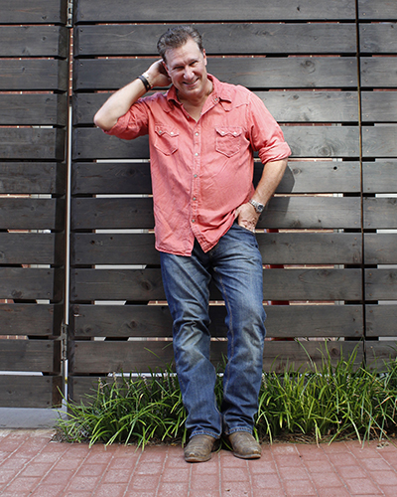  8x10 jpg | 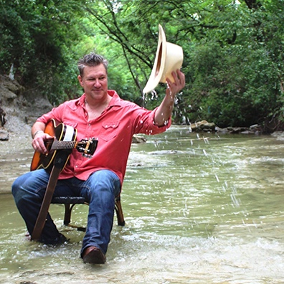  8x8 jpg | 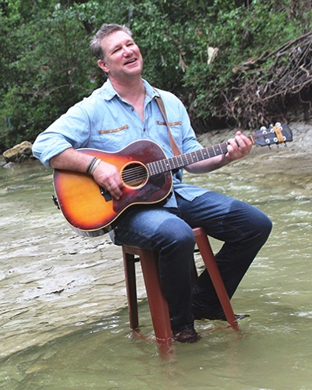  8x10 jpg
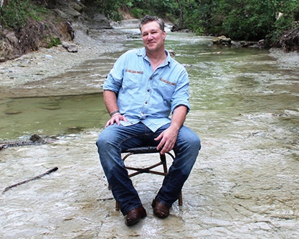  10x8 jpg | 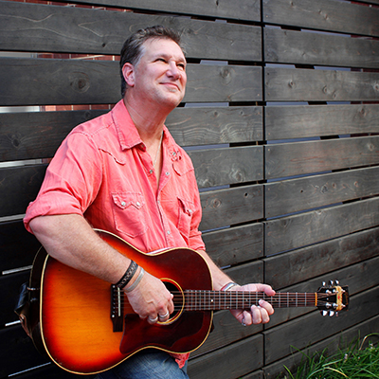  8x8 jpg | 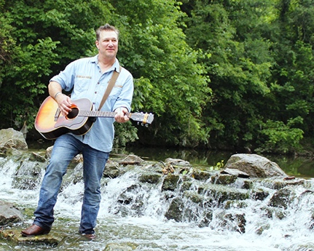  10x8 jpg

Press Quotes:

“Cool music.”

- Jim Ladd, Legendary Rock DJ, KMET, KLOS, Sirius XM

“Guthrie-esque and reminiscent of early John Prine”
- Mike Davies, Fatea Magazine, UK

“I love Dan’s songs and he tells really good stories.”
- Ramblin’ Jack Elliott, Legendary Folk Troubadour

“4 Stars: The touch of a true Master Craftsman Songwriter.”
- Alan Cackett, Maverick Magazine

“A rare combination of wit, emotion and vivid, Harry Chapin-esque imagery.”
- Rick Foster, The Sun Chronicle

"A master storyteller with a great sense of humor with influences of Robert Earl Keen and Guy Clark."
- Craig Bernhardt, Beggar’s Banquet Concerts

"Where his genius truly lies is in his ability to connect and uplift an audience."
- Denice Bruce, Badger Mountain Sessions

“Dan Weber is the Classic Mid-Life Overnight Sensation”
- Matt Miner, Matt Miner Presents

"A GREAT storyteller. Insightful and awfully funny!"
- Catherine Wood, Concert at the Woods

Stages Played:

Festivals:

Woody Guthrie Folk Festival, Okemah, OK
Kerrville Folk Festival, Kerrville, TX
Sisters Folk Festival, Sisters, OR
Falcon Ridge Folk Festival, Hillsdale, NY
Dripping Springs Songwriter's Festival, Dripping Springs, TX
Roots on the River Festival, Bellows Falls, VT
American River Music Festival, Coloma, CA
Red Ants Pants Music Festival, White Sulphur Springs, MT
Walnut Valley Festival, Winfield, KS
NW Folklife Festival, Seattle, WA
South Florida Folk Festival, Ft. Lauderdale, FL
Tumbleweed Music Festival, Richland, WA

Plymouth Folk and Blues Festival, Plymouth, VT
Tucson Folk Festival, Tucson, AZ
Connecticut Folk Festival, New Haven, CT

Conferences, Showcases and Music Series:

FAI - Folk Alliance International - Official Showcase 2022
FARM - Folk Alliance - Official Showcase 2013, 2018
NERFA - Folk Alliance - Official Showcase 2017
FAR-West - Folk Alliance - Official Showcase 2015
SERFA - Folk Alliance - Official Showcase 2015
SWRFA - Folk Alliance - Official Showcase 2014

WFMT / Folkstage, Chicago IL
Two Way Street Coffeehouse, Downers Grove, IL
Rose Garden Coffeehouse, Mansfield, MA
Uncle Calvin’s, Dallas, TX
Lake County Folk Club, Grayslake, IL
Linden Tree Coffeehouse, Wakefield, MA
Acoustic Brew Concert Series, Lemont, PA
Grassroots Concerts, Nisswa, MN
Columbus Folk Music Society, Columbus, OH
Six on the Square, Oxford, NY
Artichoke Music, Portland, OR

Seattle Folklore Society, Seattle, WA
Black Hawk Folk Society, Mt. Morris, WI
Winterfolk, Portland, OR & Riverfolk, Astoria, OR
Sundilla Acoustic Concert Series, Auburn, AL
Winter Wind Concert Series, Norman, OK
Three Rivers Folklife Society, Pasco, WA
Portland Folk Music Society, Portland, OR

Venues and Arts Centers:

Godfrey Daniels, Bethlehem, PA
Uncommon Ground, Chicago, IL
Jammin’ Java, Vienna, VA
The Blue Door, Oklahoma City, OK
Anderson Fair, Houston, TX
The Freight and Salvage, Berkeley, CA
Mississippi Studios, Portland, OR
Nashville Side Streets, Nashville, TN
Poor David's, Dallas, TX
The Big Easy, Petaluma, CA
Aladdin Theater, Portland, OR
Newport to Nashville, Newport, RI
Alberta Rose Theater, Portland, OR
Red Rock Center for the Arts, Fairmont, MN
Northwind Arts Center, Port Townsend, WA
Columbia Center for the Arts, Hood River, OR
Wildwood Park for the Arts, Little Rock, AR
Peninsula Performing Arts Center, Long Beach, WA
Chehalem Cultural Center, Newberg, OR
The Axe and Fiddle, Cottage Grove, OR
Bull Run Restaurant, Shirley, MA
The Green Frog, Bellingham, WA

Awards:

Woody Guthrie Songwriting Competition:
2019 Winner, 2014 2nd Place, 2013 3rd Place.

Kerrville Folk Festival ‘New Folk’ Competition:
2021 Finalist, 2015 Finalist, 2014 Finalist, 2012 Finalist

Winfield, Kansas Walnut Valley Festival ‘NewSong’ Showcase:
2015 Winner

Rose Garden Coffeehouse Performing Songwriter Competition:
2015 Winner

Falcon Ridge Folk Festival/Grassy Hill Emerging Artist Showcase:
2019 Finalist, 2015 Finalist

Songwriter Serenade Competition:
2016 Semi-Finalist

Great River Folk Festival Songwriting & Performing Contest:
2021 Finalist

Dave Carter Memorial Songwriting Contest, Sisters Folk Festival:
2010 Finalist

Has shared the stage with:

Ian Tyson, John McCutcheon, Ramblin’ Jack Elliot, Tom Russell, Michael Martin-Murphey, David Mallett, Steve Poltz, Greg Trooper, David Olney, Chuck Pyle, Catie Curtis, Jonathan Byrd, Danny Schmidt, Peter Mulvey, Carrie Elkin, Ben Bedford, Jon Langford, Tom May, Chris Sand, and more…

